2020Unique Boutique Application  Sunday, June 28, 2020 10 a.m. - 4 p.m.  Arlington Hts. Historical Society Grounds,  110 W. Fremont, Arlington Heights | 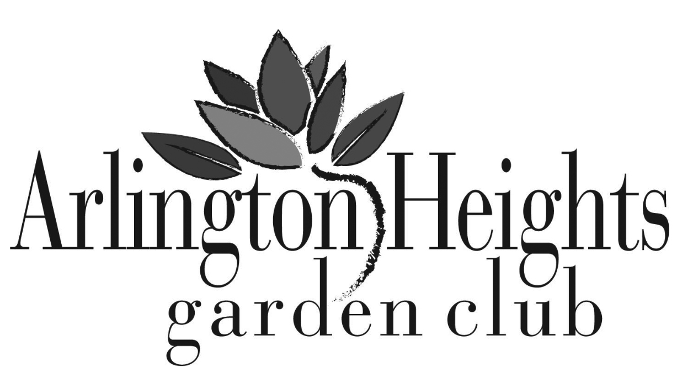

Contact Information
Name
Business Name
Business ID
City ST ZIP Code
Cell Phone
Home Phone
Work Phone
E-Mail Address
Web Site

Fees
By 4/30 5/1-6/1 # of Booth Electricity Total Due
$50/Booth $60/Booth Spaces $5

Boutique Alumni ___ Yes ___ No Tent/Canopy ___ Yes ___ No

Special Considerations

Product Description

We are committed to providing UNIQUE, high-quality items to our guests. Please list your products, the price points of each, and a brief description below. Photos of the products should be included for the web site listing.
Product Name | Price Range | Description/Methodology

Agreement and Signature

I understand that if the work I display is different from that listed on this application, I may be required to leave the show with no refund of any portion of my booth fee. I understand that neither the Arlington Heights Garden Club or the Arlington Heights Historical Society, nor any of their officers, staff or volunteers is responsible for any losses, property damage or personal injury occurring before, during, or after the Unique Boutique.
Signature
Date

Program Guide Listing
- Complete the following for the Program Guide/Web Site and submit by 6/1. We can accept applications after 6/1 but cannot guarantee they will be in our guide. The information will be printed as you list it.
- Please decide what information you would like to use as contact information, i.e. cell phone, e-mail, other.
- You are not required to include ALL of your contact information, so please choose what is best for you.
- You will have up to 3 lines for name/contact information and two lines to list or describe your products.
Sample Listing:
Unique Boutique Jane Smith
110 W. Fremont 847.555.5555
Arlington Heights, IL Jsmith@yahoo.com
Unusual products for the garden.
Birdhouses, gourds, windchimes, garden iron, pottery, furniture, herbal blends

_______________________________________ ____________________________________________
Business Name Name of Vendor
_______________________________________ ____________________________________________
Address: Street Phone: Business/Cell/Home
_______________________________________ ____________________________________________
Address: City/State/Zip E-Mail and Web Site
Description
________________________________________________________________________________________

________________________________________________________________________________________

Raffle Donation
- One of the features of the Boutique is a raffle with prizes donated from club members, local businesses, and our vendors. A raffle donation is requested, but not required.
- Are you willing to donate an item to the raffle? ___ Yes ___ No

Item to be Raffled _______________________________________ $ Value _____________________

Completed Application
- Complete both pages of application
- Check payable to Arlington Heights Garden Club (AHGC)
- (3) Photographs of your product/process
- Send to: Barb Franks, 908 W. Campbell St., Arlington Hts., IL 60005
barbarafranks908@gmail.com (847) 612-8892

