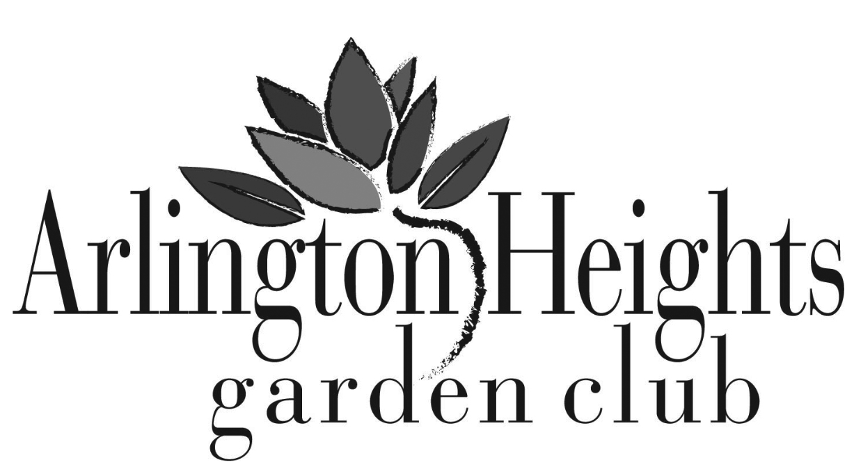
The Arlington Heights Garden Club is hereby authorized to include our company as a proud sponsor,
as indicated below, of its annual Garden Walk and Unique Boutique on Sunday, June 28, 2020.
Proceeds will benefit civic, educational and environmental programs in the community.

EVENT SPONSORSHIP

Selection | Sponsorship Level | Donation | Sponsorship Includes
 | Platinum | $500+ | Full page ad in program book, logo on sign, four complimentary tickets to the event
 | Gold | $250+ | One half page ad in program book, logo on sign, two complimentary tickets to the event
 | Silver | $100+ | One quarter page ad in program book, name mention on sign
*All three sponsorship levels will be acknowledged on the Arlington Heights Garden Club webpage

PROGRAM BOOK ADVERTISING
Ads should have a resolution of 300 dpi and be provided in either pdf, png or eps format and sized per the dimensions purchased. Please provide a black and white ad and an optional color ad for the web if you are a sponsor. The cost and sizes are:

___ Full Page Ad (7½ H X 4½” W) $200 ___ Quarter Page Ad (3½”H X 2” W) $50

___ Half Page Ad (4½” H x 3½” W) $100 ___ Listing as Friend of AHGC $25

Please e-mail ads to patdennehey@wowway.com

MERCHANDISE/SERVICES DONATION - Due by May 15, 2020

Please accept our item(s) for donation ________________________________ Valued at: $____________

PLEASE COMPLETE THE FOLLOWING:
Business Name:
Contact:
Mailing Address:
Telephone:
Email Address:
Signature

Please make checks payable to “Arlington Heights Garden Club”.
Send donations to: AHGC c/o Pat Dennehey
1411 N. Hickory Ave.
Arlington Heights, IL 60004
For Additional Questions or to make arrangements for a donation pick up - Please contact Pat Dennehey at: (847)255-0133 or patdennehey@wowway.com

